caXchange Performance Analysis
Version No : Initial Draft
Last Modified : 12/12/2008

Team : caXchange Team
Client : National Cancer Institute,
National Institutes of Health,
US Department of Health and Human Services

Document History

Document Location
The most current version of this document is located in CVS under http://gforge.nci.nih.gov/plugins/scmcvs/cvsweb.php/caxchange/Documentation/Testing/caXchange%20Performance%20Analysis.doc?cvsroot=caxchange

Revision History
Version Number | Revision Date | Author | Summary of Changes
0.1 | 12/12/2008 | Harsh Marwaha | Initial Draft

Review
Name | Team/Role | Version | Date Reviewed | Reviewer Comments
Kalpesh Patel | Architect | 0.1

Approval
Name | Team/Role | Version | Date Reviewed | Reviewer Comments

1 Goals 4
2 Description 4
3 Performance Analysis 5
3.1 SCHEDULE_MODIFICATION 5
3.2 STUDY_CREATION 6
3.3 Profiling 8
4 Strategies for Improvements 8

Goals
The goal of this exercise is to analyze performance of caXchange request processing and suggest possible improvements. This document details a breakup of the processing time of a request within caXchange.

Description
This performance analysis was done on a machine with the following characteristics:
- OS: Microsoft Windows XP Professional Version 2002 Service Pack 2
- Processor: Intel Core 2 Duo CPU E6750 @ 2.66 GHz
- Memory: 1.96 GB
caXchange Inbound grid service and caXchange hub were deployed on the above machine. The Global Model Exchange, and the Credential Delegation Service used for payload validation and target service authentication were deployed on the CCTS development server cbvapp-d1017.nci.nih.gov. The target services used for these tests were also deployed on the CCTS development server.
caXchange auditing was disabled for these tests by disabling the corresponding log4j configuration.
The performance analysis was done by logging the time taken for each step in the processing of a request. The tests were initiated using the integration smoke tests. This helped identify where most of the time was spent processing a request. Analysis was done for SCHEDULE_MODIFICATION and STUDY_CREATION requests. These requests represent two typical services in caXchange. SCHEDULE_MODIFICATION is an example of a service which does not participate in reliable transactions on the other hand STUDY_CREATION has a different routing as it participates in reliable transactions.
Additional analysis was done using java profiler. Profiling for the Servicemix and Tomcat containers was done using the Yourkit Java Profiler version 7.5.11. This helped identify the bottle necks at the package and class level.

Performance Analysis

SCHEDULE_MODIFICATION

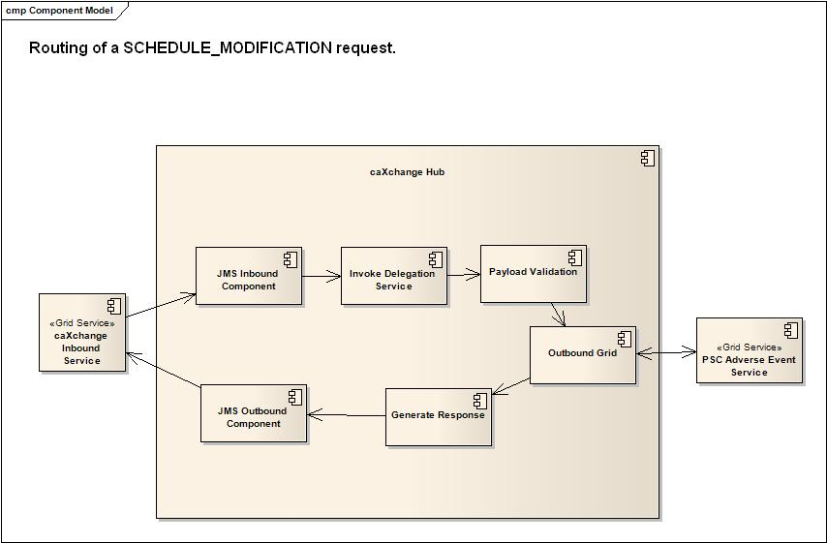
Figure 1 Routing for a SCHEDULE_MODIFICATION request.

The figure above shows the routing of a SCHEDULE_MODIFICATION request once it is received in caXchange. Each component within caXchange hub is a Servicemix Bean service unit. Each component is integrated into the routing using a Servicemix Enterprise Integration Pattern (EIP) Pipeline component. The current interface of caXchange requires polling for the response. The polling interval configured on the client can add to the total response time. For the purpose of these tests the total response time for caXchange was calculated from the time caxchange received the request to the time the response was available to the client. 30 requests were sent to caXchange. The table below gives the average results of these tests (the times are in milliseconds):

Service | Total Time | Invoke Delegation Service |  | Payload Validation |  | Invoke Target Services |  | Generate Response |  | Other time in caXchange
SCHEDULE_MODIFICATION | 1438 | 449 | 31.22% | 8 | 0.05% | 354 | 25% | 20 | 1.4% | 607 | 42%
Table 1 Processing of a SCHEDULE_MODIFICATION request.

This table above shows that a significant amount of time is spent for external resources. Invocation of the delegation service takes a significant amount of time and so does invoking the target service. The time spent invoking the target service would have been spent any way if the client invoked the target service directly. Additionally a significant amount of time (42%) is spent in caXchange which can provide an opportunity for improvement. Further logging found that most of this time was spent in between the caXchange service units while the message was flowing through the Servicemix Normalized Message Router (NMR) and the Servicemix EIP components. There was an average of 60 milliseconds delay between the requests being sent from one service unit to the request being received in the next service unit.

STUDY_CREATION

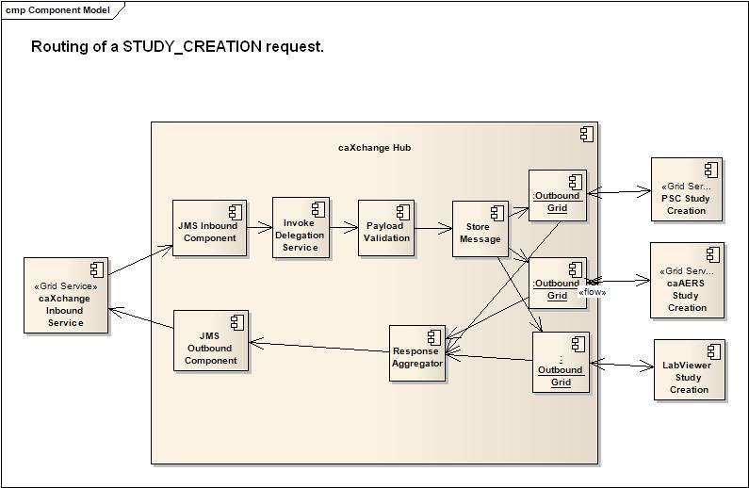
Figure 2 Routing for a STUDY_CREATION request.

The table below gives the average results of these tests for the STUDY_CREATION service:
Service | Total Time | Invoke Delegation Service |  | Payload Validation |  | Store Message |  | Invoke Target Services (3 services invoked in parallel) |  | Response  Aggregator |  | Other time in caXchange
STUDY_CREATION | 3100 | 408 | 14% | 7 | 0% | 30 | 1% | 668 | 22% | 260 | 3% | 1757 | 57%
Table 2 Processing of a STUDY_CREATION request.
This shows similar results. A significant amount of time (57%)is spent in caXchange between the processing units. There are more hops between service units for STUDY_CREATION because of multiple target services and reliable transactions.

Profiling
In order to gain insight into where the time was being used in caXchange profiling was done for caXchange Inbound service and caXchange hub software. It was found that even though the caXchange auditor was disabled it was consuming a significant amount of time. The caXchange auditor is deployed as an event listener to caXchange. It is invoked for each hop within caXchange. It was found that disabling the caXchange auditor at the Log4j level just disables the logging of exchanges; the caXchange auditor functionality is still invoked.
Testing was done with the caXchange auditor disabled completely so that the auditor is not invoked at all.
Service | Total Time | Invoke Delegation Service |  | Payload Validation |  | Invoke Target Services |  | Generate Response |  | Other time in caXchange
SCHEDULE_MODIFICATION | 1051 | 447 | 43% | 8 | 0.1% | 350 | 33% | 20 | 1.9% | 246 | 23%
Table 3 Processing SCHEDULE_MODIFICATION with auditing completely disabled.
As can be seen from the table above there was a significant reduction in the time spent in caXchange. The major bottle neck now is the delegation service. The time spent to invoke the target service would any way be spent if the client was invoking the target service directly. Additional logging showed that the amount of time spent between service units was reduced to almost 0ms.

Strategies for Improvements
- Re-architect and re-design the caXchange auditor so that auditing is not too much of an overhead. Possibly reduce the number of exchanges being audited. For example only the incoming request and the outgoing response are audited.
- Cache delegated credentials to reduce the number of delegation service invocations.
- Route messages to reduce the number of Enterprise Integration Pattern (EIP) components. For example instead of using a sequence of EIP pipeline components each invoking a separate service unit, use a single EIP routing slip to route messages to all beans.

